DEVELOPMENT AND EXPLANATION
MicroGoals:
- Do 10 push-ups today
- Walk 15 minutes
- Drink 2 liters of water
- Sleep before 11 PM
Small steps like these make progress easier and reduce overwhelm.
How the MicroGoal method works
- Pick one small action
- Do it every day for a short period (often 7 days)
- Track done / skipped
- Reset and start the next week
Many apps use this 7-day sprint habit system so motivation stays high without long streak pressure.
Why people use MicroGoals
- 🧠 Less stress than big goals
- 🚀 Builds momentum with small wins
- 📈 Consistent progress over time
- ❌ No “failure pressure” if you miss a day
Simple real-life MicroGoal examples
- Read 2 pages a day
- Study 10 minutes
- Write 1 paragraph
- Save ₹50 per day

✅ If you want, I can also show:
- 10 MicroGoal examples for students
- MicroGoal template (daily tracker)
- How to design MicroGoals for studying or business.
**MicroGoals**
MicroGoalsd : development and explanation
MicroGoals – Development & Explanation
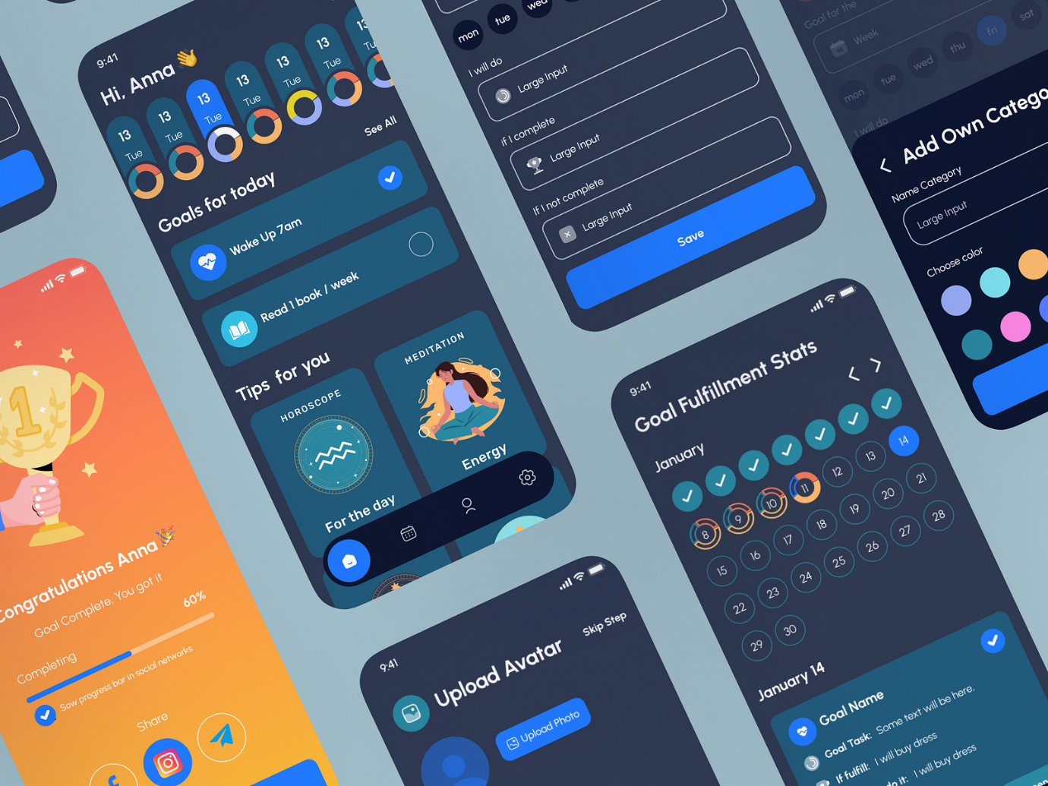

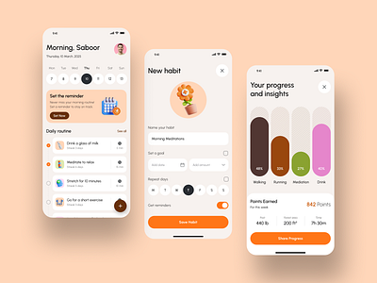
4
1. What are MicroGoals?
MicroGoals are very small, simple actions that help achieve a larger goal gradually. Instead of trying to complete a big task all at once, the goal is broken into tiny daily steps.
Formula
Big Goal → Mini Tasks → MicroGoals → Daily Completion
Example
Big Goal: Learn Programming
MicroGoals:
- Day 1: Learn variables
- Day 2: Write 5 lines of code
- Day 3: Practice one exercise
- Day 4: Read documentation for 10 minutes
Each step is small enough to complete easily.

2. Development of the MicroGoals Concept
The MicroGoals idea developed from several psychology and productivity theories.
1️⃣ Behavioral Psychology
Researchers found that small achievable tasks increase motivation.
Related idea:
- Operant Conditioning
When people complete small tasks:
- Brain releases dopamine
- Motivation increases
- Habit forms faster

2️⃣ Kaizen Philosophy
Another influence is the Japanese improvement philosophy:
- Kaizen
Kaizen principle:
Continuous improvement through small daily changes.
Example:
- Improve 1% every day.

3️⃣ Habit Formation Theory
Habit research (21-day / repetition models) showed that small repeated actions build habits faster than big efforts.
Related research field:
- Behavioral Psychology
This led productivity experts to promote tiny habits and micro steps.

3. How MicroGoals Work
Step 1 – Define the Main Goal
Example:
- Become fluent in English
- Lose weight
- Start a business
Step 2 – Break the Goal
Divide the big goal into small measurable actions.
Example (Learn English)
Day | MicroGoal
Day 1 | Learn 5 new words
Day 2 | Watch 5-minute English video
Day 3 | Write 3 sentences
Day 4 | Practice speaking 2 minutes

Step 3 – Track Progress
Tracking methods:
- Habit tracker apps
- Daily checklist
- Calendar marking
Example tracking:
Day 1 ✓
Day 2 ✓
Day 3 ✓
Day 4 ✓

4. Key Characteristics of MicroGoals
Good MicroGoals should be:
1. Small
Task takes 2–15 minutes
2. Specific
Clear action
Bad:
Study math
Good:
Solve 3 math problems
3. Achievable
Should feel easy to start.
4. Daily or frequent
Consistency matters more than intensity.

5. Benefits of MicroGoals
✔ Reduces procrastination
Small tasks remove mental resistance.
✔ Builds consistency
Daily actions build habits.
✔ Quick motivation
Completing tasks gives instant success feeling.
✔ Prevents burnout
Large goals can overwhelm people.

6. MicroGoals vs Traditional Goals
Traditional Goals | MicroGoals
Large targets | Tiny tasks
Long timeline | Short daily actions
High pressure | Low pressure
Hard to start | Easy to start

7. Real-World Examples
Fitness
Big Goal → Lose weight
MicroGoals:
- Walk 10 minutes
- Drink 2L water
- Do 10 pushups

Studying
Big Goal → Pass exam
MicroGoals:
- Study 1 topic daily
- Solve 5 questions
- Revise for 10 minutes

Writing
Big Goal → Write a book
MicroGoals:
- Write 100 words daily

8. MicroGoals in Modern Apps
Many productivity apps use this idea:
Examples include habit trackers and productivity tools that encourage short daily actions.

✅ If you want, I can also explain:
- MicroGoals app system design (how to build the app)
- MicroGoals algorithm / logic
- MicroGoals research paper style explanation (for project or assignment).

We use cookies
We use cookies to help this site function, understand service usage, and support marketing efforts. Visit Manage Cookies to change preferences anytime. View our Cookie Policy for more info.
Example
Big goal: Get fit
MicroGoals:
- Do 10 push-ups today
- Walk 15 minutes
- Drink 2 liters of water
- Sleep before 11 PM
Small steps like these make progress easier and reduce overwhelm.
How the MicroGoal method works
- Pick one small action
- Do it every day for a short period (often 7 days)
- Track done / skipped
- Reset and start the next week
Many apps use this 7-day sprint habit system so motivation stays high without long streak pressure.
Why people use MicroGoals
- 🧠 Less stress than big goals
- 🚀 Builds momentum with small wins
- 📈 Consistent progress over time
- ❌ No “failure pressure” if you miss a day
Simple real-life MicroGoal examples
- Read 2 pages a day
- Study 10 minutes
- Write 1 paragraph
- Save ₹50 per day

✅ If you want, I can also show:
- 10 MicroGoal examples for students
- MicroGoal template (daily tracker)
- How to design MicroGoals for studying or business.
**MicroGoals**
MicroGoalsd : development and explanation
MicroGoals – Development & Explanation



4
1. What are MicroGoals?
MicroGoals are very small, simple actions that help achieve a larger goal gradually. Instead of trying to complete a big task all at once, the goal is broken into tiny daily steps.
Formula
Big Goal → Mini Tasks → MicroGoals → Daily Completion
Example
Big Goal: Learn Programming
MicroGoals:
- Day 1: Learn variables
- Day 2: Write 5 lines of code
- Day 3: Practice one exercise
- Day 4: Read documentation for 10 minutes
Each step is small enough to complete easily.

2. Development of the MicroGoals Concept
The MicroGoals idea developed from several psychology and productivity theories.
1️⃣ Behavioral Psychology
Researchers found that small achievable tasks increase motivation.
Related idea:
- Operant Conditioning
When people complete small tasks:
- Brain releases dopamine
- Motivation increases
- Habit forms faster

2️⃣ Kaizen Philosophy
Another influence is the Japanese improvement philosophy:
- Kaizen
Kaizen principle:
Continuous improvement through small daily changes.
Example:
- Improve 1% every day.

3️⃣ Habit Formation Theory
Habit research (21-day / repetition models) showed that small repeated actions build habits faster than big efforts.
Related research field:
- Behavioral Psychology
This led productivity experts to promote tiny habits and micro steps.

3. How MicroGoals Work
Step 1 – Define the Main Goal
Example:
- Become fluent in English
- Lose weight
- Start a business
Step 2 – Break the Goal
Divide the big goal into small measurable actions.
Example (Learn English)
Day | MicroGoal
Day 1 | Learn 5 new words
Day 2 | Watch 5-minute English video
Day 3 | Write 3 sentences
Day 4 | Practice speaking 2 minutes

Step 3 – Track Progress
Tracking methods:
- Habit tracker apps
- Daily checklist
- Calendar marking
Example tracking:
Day 1 ✓
Day 2 ✓
Day 3 ✓
Day 4 ✓

4. Key Characteristics of MicroGoals
Good MicroGoals should be:
1. Small
Task takes 2–15 minutes
2. Specific
Clear action
Bad:
Study math
Good:
Solve 3 math problems
3. Achievable
Should feel easy to start.
4. Daily or frequent
Consistency matters more than intensity.

5. Benefits of MicroGoals
✔ Reduces procrastination
Small tasks remove mental resistance.
✔ Builds consistency
Daily actions build habits.
✔ Quick motivation
Completing tasks gives instant success feeling.
✔ Prevents burnout
Large goals can overwhelm people.

6. MicroGoals vs Traditional Goals
Traditional Goals | MicroGoals
Large targets | Tiny tasks
Long timeline | Short daily actions
High pressure | Low pressure
Hard to start | Easy to start

7. Real-World Examples
Fitness
Big Goal → Lose weight
MicroGoals:
- Walk 10 minutes
- Drink 2L water
- Do 10 pushups

Studying
Big Goal → Pass exam
MicroGoals:
- Study 1 topic daily
- Solve 5 questions
- Revise for 10 minutes

Writing
Big Goal → Write a book
MicroGoals:
- Write 100 words daily

8. MicroGoals in Modern Apps
Many productivity apps use this idea:
Examples include habit trackers and productivity tools that encourage short daily actions.

✅ If you want, I can also explain:
- MicroGoals app system design (how to build the app)
- MicroGoals algorithm / logic
- MicroGoals research paper style explanation (for project or assignment).

We use cookies
We use cookies to help this site function, understand service usage, and support marketing efforts. Visit Manage Cookies to change preferences anytime. View our Cookie Policy for more info.

